**NATIONAL INSTITUTE OF TECHNOLOGY KARNATAKA SURATHKAL**

**DEPARTMENT OF INFORMATION TECHNOLOGY**

**IT351 - Human-Computer Interaction**

**Lab Assignment -1: Serial Position Effect**

**Submitted by Bhagyashri Bhamare , 181IT111**

**Serial-position effect** is the tendency of a person to recall the first and last items in a series best, and the middle items worst. When asked to recall a list of items in any order people tend to begin recall with the end of the list, recalling those items best (the **recency effect**). Among earlier list items, the first few items are recalled more frequently than the middle items (the **primacy effect**)

Serial Position Effect experiment-

GUI to understand Serial-position effect

Read the list animals sequentially within a stipulated time. Then choose the items in the list freely. Record the recall frequencies of these animals.

Results-

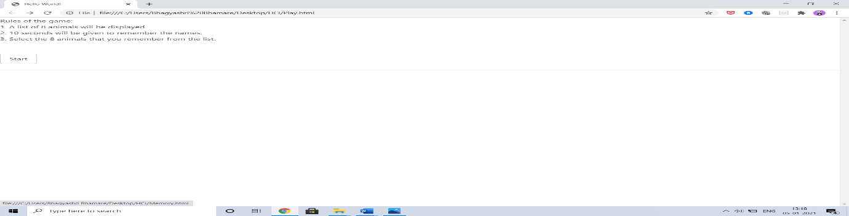

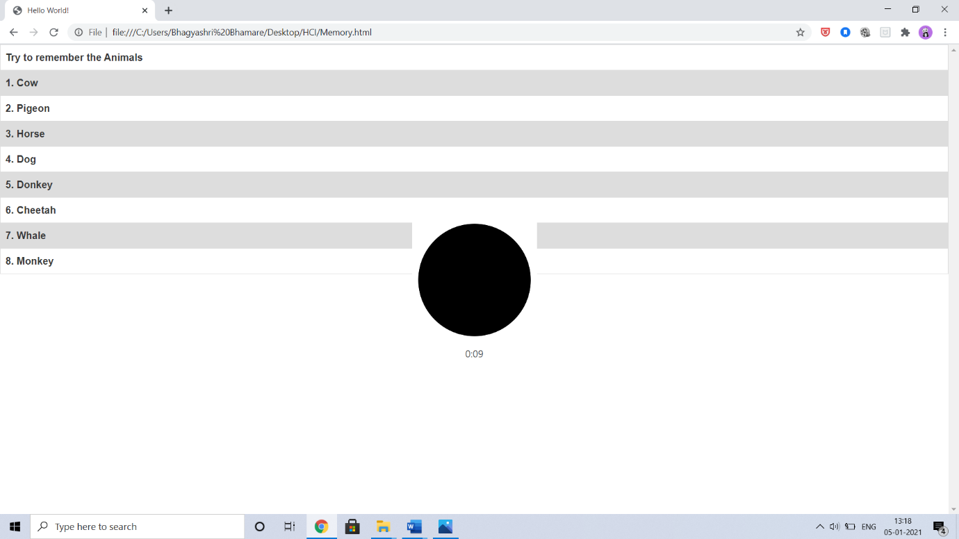

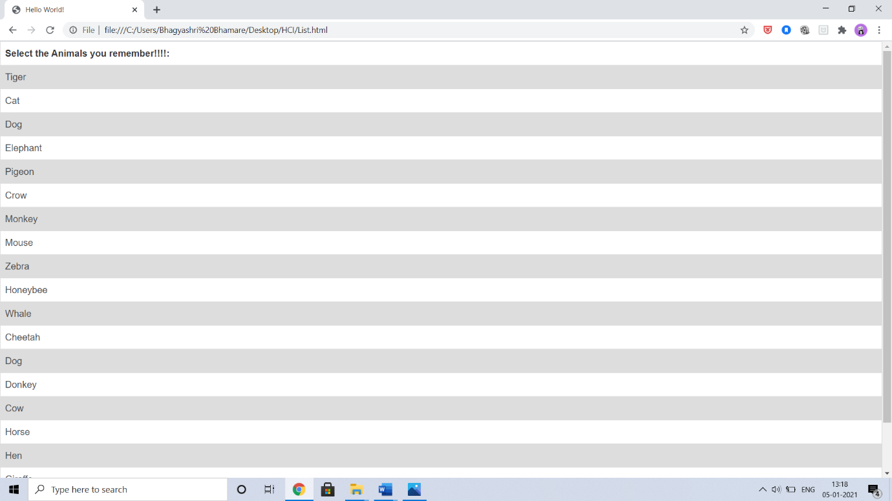



Time given to each participant to go through the list - 10 seconds

List of aniamls to remember-

Cow, Pigeon, Horse, Dog, Donkey, Cheetah, Whale, Monkey

List of animals -

Tiger,Cat,Dog,Elephant,Pigeon,Crow,Monkey,Mouse,Zebra,Honeybee,Whale,Cheetah,Dog,Cow,Hors-e,Hen,Giraffe

ANALYSIS OF RESULTS:

Percentage of total time we got correct animal-

1. Cow -100%

2. Pigeon-95%

3. Horse-83%

4. Dog- 76%

5. Donkey-58%

6. Cheetah-46%

7. Whale-98%

8. Monkey-100%

For better understanding, the above information has been represented graphically :

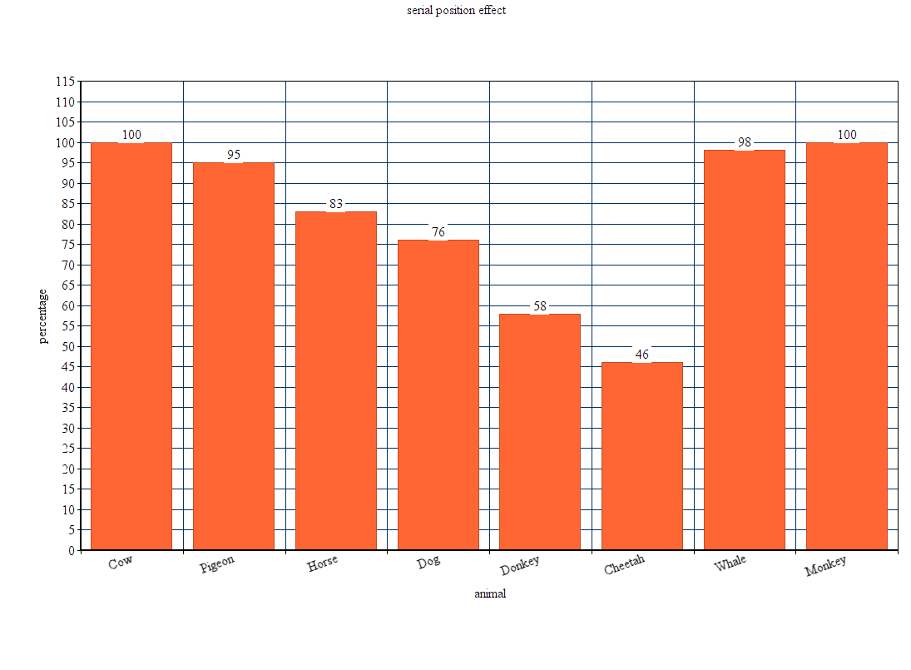

Analysis-

1) The primary and recency effects do play a major role in recalling the animal names as

we can clearly see that the animals in the first few and the last few positions have a high

percentage of recall compared to the animals in the other positions.

2)Most of the people remember money.because of popularity

3)Due to personal bias Dog and Donkey are guessed correctly

4) On performing the experiment multiple times, it was observed that individuals tend to recall more

animals from the list.

This experiment proves the Serial Position Effect.